
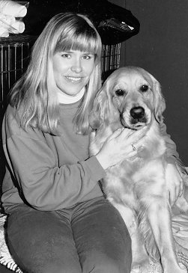
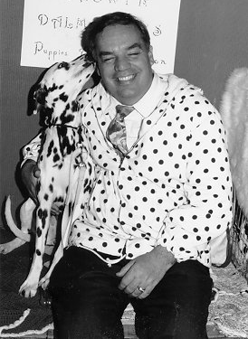
Do You Look Like Your Dog?

Do You know Someone Who Does?

We’re looking for photos for our follow-up book to
DO YOU LOOK LIKE YOUR DOG? to be published by Broadway Books, a Random House division, in January 2004. Our photo deadline is December 1. Visit us at www.doyoulooklikeyourdog.com and see over 400 photos sent from all over the world.
Photos will also be included in our Do You Look Like Your Dog competition, which is featured on our Web site and not related to the book. There are prizes for winners — plans for a TV show and we’re looking for sponsors. Contact us at our Web site or at:
Do You Look Like Your Dog
6114 La Salle, #358
Oakland, CA 94611
(510) 339-1625
FAX: 339-1626
DogDaysBark@aol.com

